- Bluebook Page20 August 2019 Variant One examination:

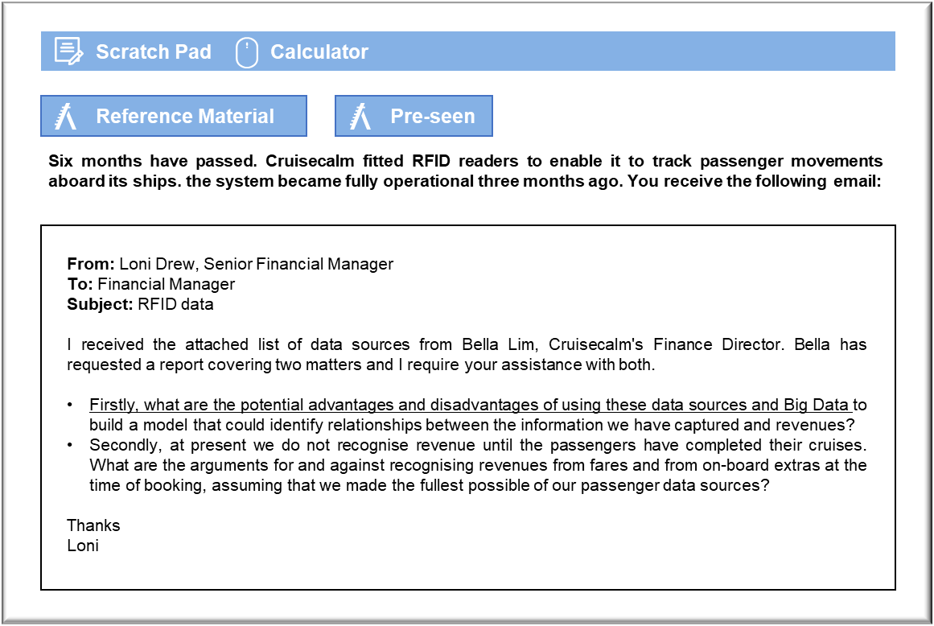

MANAGEMENT CASE STUDY AUGUST 2019 EXAM ANSWERS

Variant1 Task2
These answers have been provided by CIMA for information purposes only. The answers created are indicative of a response that could be given by a good candidate. They are not to be considered exhaustive, and other appropriate relevant responses would receive credit.

CIMA will not accept challenges to these answers on the basis of academic judgement.

Requirement 1: Big Data analytics

The first advantage is that Big Data analytics would enable Cruisecalm to draw inferences from the whole set of data that it holds. There could, for example, be relationships between answers to specific questions on the customer satisfaction surveys that influence the likelihood of a repeat booking. Studying the responses in isolation of booking files might not enable the company to see the relative importance of satisfaction in particular areas of the passenger experience. It may be, for example, that passengers will make a repeat booking provided the ship was clean or provided they found the crew friendly.

Once the model has been constructed, Cruisecalm will be able to run it repeatedly in order to establish whether any of the factors have changed in importance. For example, whether changes to the restaurant menus have had an impact on overall passenger satisfaction. Apart from anything else, that would give Cruisecalm a basis for checking the impact that any changes made in response to previous feedback have had. Hopefully, there will be signs of increased passenger satisfaction and an increase in the number of repeat bookings.

Big Data analytics could have a number of disadvantages. For example, the underlying data might not be particularly helpful, because it is not always fully representative. One obvious issue is that the customer satisfaction surveys are completed by only 30% of passengers, which could create a significant problem because of non-response bias. If, say, unhappy passengers are more likely to take the trouble to complete the survey, then Cruisecalm could be tempted to make changes to its cruises that take no account of the views of the passengers who enjoyed themselves, but who choose not to take the time to complete the survey .

Big Data analytics do not necessarily develop a causal model and could produce misleading results. For example, passengers’ experiences could have been affected by bad weather during their cruise, which meant that they did not enjoy themselves. If Cruisecalm had not taken account of such external factors then it could draw incorrect conclusions from the results of its analysis of the data that it has collected internally. It may also be difficult to measure key variables, such as the proportion of passengers who go on to make repeat bookings. Many passengers will not book their next holiday for several months after their return and so that data will not be available unless Cruisecalm revisits the historical responses some time later .

Requirement 2: Revenue recognition

Cruisecalm enjoys two sources of revenue from its passengers, namely the fare for the cruise itself and the on-board extras that passengers are likely to buy once aboard ship. Cruisecalm could argue that the booking constitutes a binding agreement with respect to the cruise fare and that the completion of the booking process commits the passenger to making payment in full . The fact that the passenger is required to pay a substantial deposit further supports the argument that the passenger’s fare could be regarded as a receivable at the time of booking.
The revenues from other on-board items is less clear cut, but an argument could be made. Cruisecalm’s data indicates that there is a clear expectation that the vast majority of passengers will make purchases while on board and so it could be argued that those expectations can be expected to arise from the date of booking.

The arguments relating to the recognition of cruise fares can be best evaluated against the requirements of IFRS 15 Revenue from Contracts with Customers. The booking falls within the requirements of IFRS 15 and meets some of the criteria for recognition. For example, Cruisecalm is capable of identifying the rights and obligations of both parties and can identify the payment

